
Year 9 Science 2024 Name: __________________

Earth & Space Test 1: Plate Tectonics

SECTION 1: MULTIPLE CHOICE (1 mark each)
Circle your answer.

The first five questions are about the following diagram of the structure of the Earth.
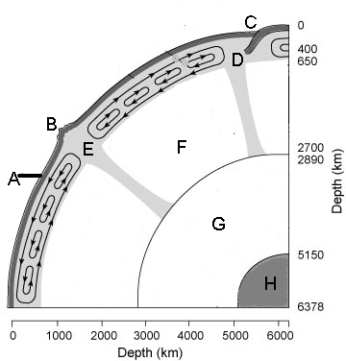

- The part of the Earth that is labelled A is called the:
  - Crust.
  - Lithosphere
  - Asthenosphere
  - Mantle

- Which of Earth’s layers is made of solid Iron?
  - E
  - F
  - G
  - H

- The area that is labelled D is called:
  - Subsection.
  - Subduction
  - Expansion.
  - Divergent

- The asthenosphere is found where?
  - A
  - B
  - E
  - D
- The thickness of the liquid outer core is approximately:
  - 2050km
  - 5200km
  - 2900km
  - 5100km

- The crust and upper mantle are known as the?
  - Atmosphere
  - Lithosphere
  - Asthenosphere
  - Outer-sphere

- Earthquakes produce waves known as:
  - Summer waves
  - Sound waves
  - Seismic waves
  - Sub tidal waves

- Which features are not found where the plates in the Earth’s crusts are being pushed together?
  - Volcanoes
  - Mountain ranges
  - Mid-ocean ridges
  - Oceanic trenches

- The “ring of fire” is a circle of volcanoes around the edge of the:
  - Indian Ocean.
  - Antarctic Plate.
  - Nazca Plate.
  - Pacific Ocean.

- Tsunamis are also known as:
  - Earthquakes.
  - Volcanoes.
  - Fault lines.
  - Tidal waves.

- Earthquakes are caused by:
  - Friction, tension and sudden slippage of crustal plates.
  - Friction, heat and melting of crustal plates.
  - Fractures or cracks in the middle of crustal plates.
  - Crustal plates moving apart.

- Which statement about Earthquakes is false?
  - Movements within the Earth’s crust are measured using a seismograph.
  - The point on the Earth’s surface where the Earthquake is most intense is called the epicentre.
  - Intensity of Earthquakes is measured on the Richter Scale, with every increase of one on the scale being ten times more intense.
  - Scientists can easily predict the timing, location and intensity of Earthquakes.

- The study of the movement of the Earth’s crustal plates is called:
  - Plate tectonics.
  - Geophysics.
  - Oceanography.
  - Seismology.

- Which of these is not supporting evidence for Continental Drift Theory?
  - The shape of the continents suggests that they may have once fitted together like a jigsaw puzzle.
  - Fossil evidence shows similar species at similar times on continents that are on opposite sides of large oceans.
  - Continental plates continue to slowly travel in the direction that the theory suggests they travelled in the past.
  - Historical satellite images show the super continents Pangaea and Gondwanaland.

- Which observation lead to the hypothesis of sea floor spreading?
  - claim of a large land mass called Pangaea
  - there is a global rift system of undersea mountains
  - scientists in 1952 discovered a mountain ridge in the Atlantic Ocean
  - magnetic material is laid down in stripes either side of mid ocean trenches

- Earthquakes can be measured in:
  - magnitude on the Richter Scale
  - intensity on the Wegener Scale
  - energy on the Mercalli Scale
  - depth on the Mariana Scale

The next four questions refer to the following diagram.
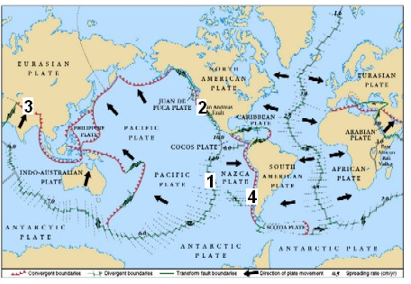
- Which type of plate boundary is found at location 1?
  - Divergent
  - Subduction convergent
  - Transform
  - Collision convergent

- Which feature would be expected at location 2?
  - Deep ocean trench
  - Mid-ocean ridge
  - Volcanoes
  - Earthquakes

- Mountain ranges caused by two continental plates colliding would be expected at location:
  - 1
  - 2
  - 3
  - 4

- Subduction convergence of thinner oceanic plates under thicker continental plates causes volcanic activity parallel to the plate boundary on the continental plate. This causes mountain ranges like those found at location:
  - 1
  - 2
  - 3
  - 4

SECTION 2: WRITTEN

- For each of the following diagrams
  - Name the type of plate boundary.
  - Name one type of feature that would be found in that location. (8)

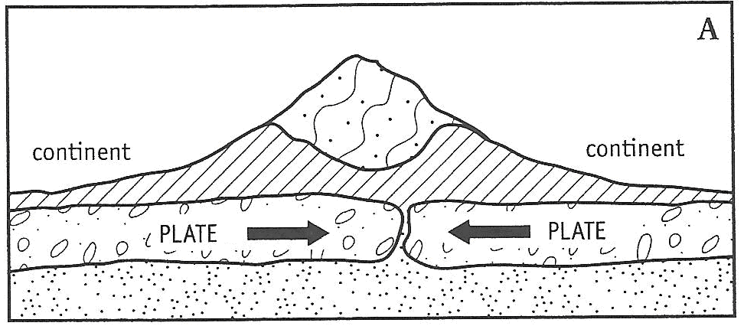
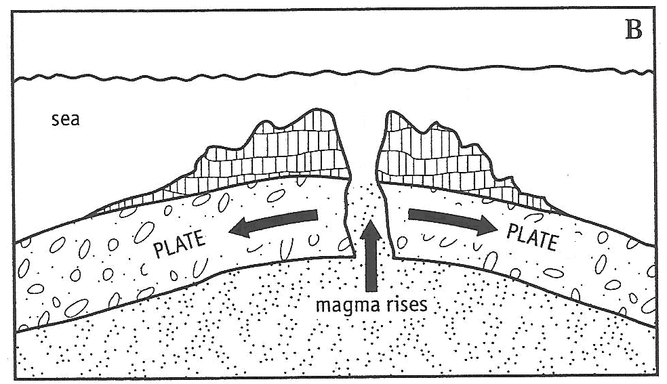

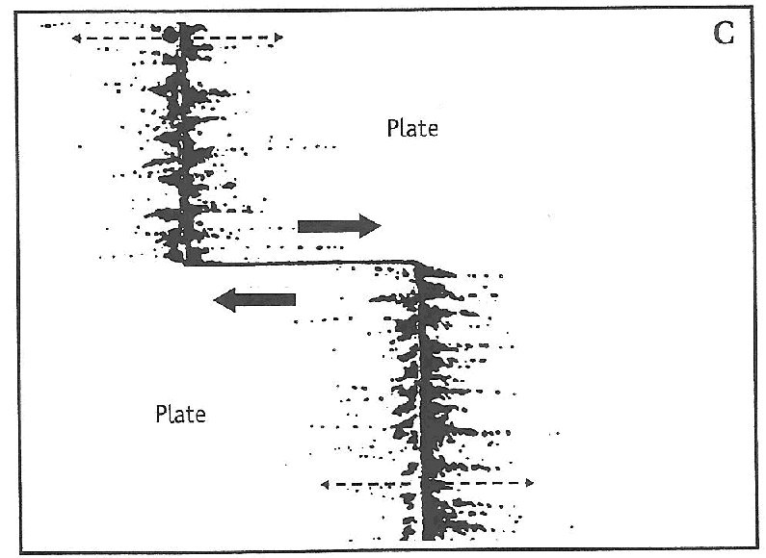
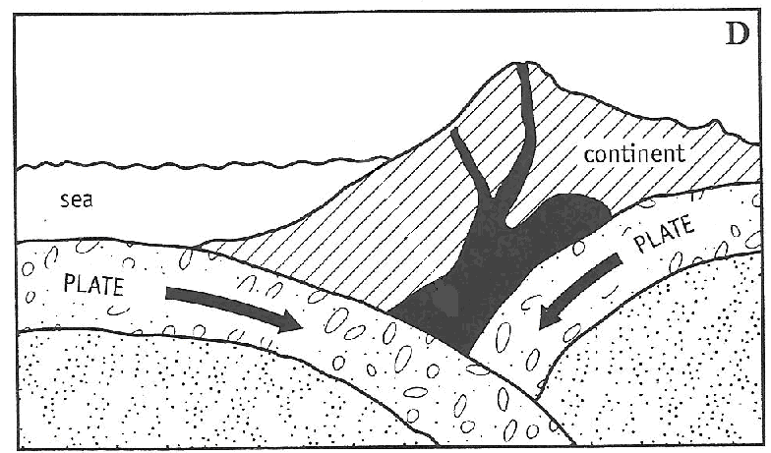

- Write the letter of the volcano parts shown on the diagram to the corresponding term in the box (7)

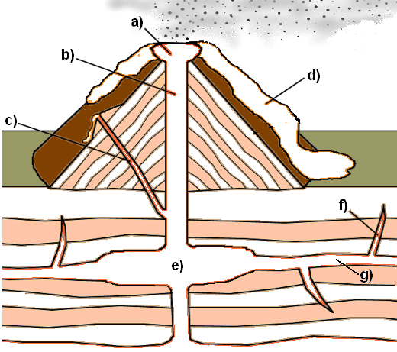

Lava
Crater
Magma Chamber
Sill
Main Vent (throat)
Side Vent
Dike

End of test (OUT OF 35 MARKS)

